**1D,2 Dimensional Array**

**1D Array**

1. Refer the code snippet and answer the queries

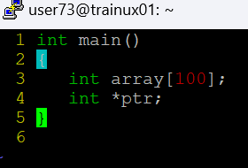

Q1: Can pointer be used in Array-style syntax? e.g. ptr[10], ptr[0]

**Yes, the pointer can be used in Array style syntax**

Q2: Can Array be used in Pointer-style syntax? e.g. *array, *(array + 0), *(array + 10)

**Yes, an array can be used in pointer style syntax**

Q3: is ptr++ valid?

**Yes, it is valid. It moves to the next address**

Q4: is array++ valid?

**It is invalid. Array address cannot be changed**

Q5: what is sizeof(array)?

**Sizeof(array) gives the total size of array**

Q6: what is sizeof(ptr)?

**Gives the sizeof ptr generally 4 bytes**

1. Refer the code snippet below. Comment on the other elements (other than those that are explicitly initialized) of all array variables in code snippet below.

#define MAX 100

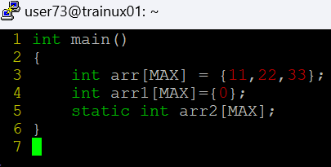

**Arr[3] to arr[99] 🡪 initialized to 0**

**Arr[0] to arr[99] 🡪 initialized to 0**

**All elements are initialized to 0 as they are static**

1. Refer the program “array_pointer.c”. Add a function getmax() to find the maximum in the array and call in main() and display the result.

**getMax() function:**

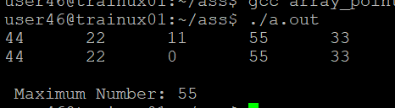

1. Extend the code given below to read N and a start value from the user to perform the given operations.

#define MAX 100

**int main()**

**{**

**int arr[MAX] = {11,22,33};**

**}**

Add the following functions choosing proper input, output and return.

1. init() - Use the inputs to initialize the first N elements of the array with N consequetive values starting with given start value .
2. update() – increment value of every element in the array
3. display() – display the contents of array

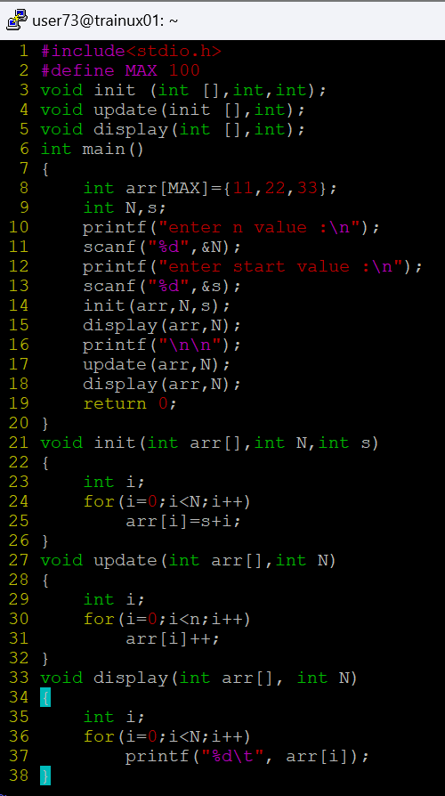

**2D, MultiDimensional Arrays**

1. Implement sort() to sort a given array. Refer the code snippet below.

**int main()**

**{**

**char arr[]= “xaybz”;**

**sort(arr, sizeof(arr)/sizeof(arr[0]);**

**return 0;**

**}**

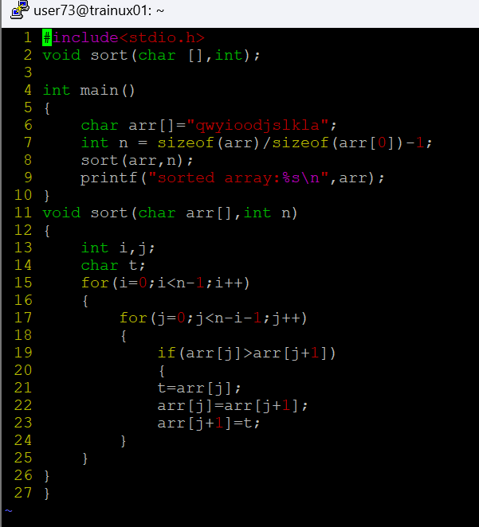

1. Refer the code snippet below.

**int main()**

**{**

**char arr[][3] = {**

**sort(arr, sizeof(arr)/sizeof(arr[0]);**

**return 0;**

**}**

Allow user to perform the following operations.

* 1. init() - initialize the array and return 0
  2. search_update() – search for a given element in array and if found update it to given value and return 0 else return 1
  3. display() – traverse and display array contents

For the functions, pass array and other required arguments to functions and return as per requirement

